

**Search Engine Optimization(MKT 905)**

Final report

Submitted To: Abhishek Sahai

Submitted By:

Name: Andol Saketh

Reg.No: 12221210

Roll No: RKO029B64

**Link of Website:**

<https://avintageglory.weebly.com/>

**Theme of website:**

A Vintage Glory celebrates the charm of timeless treasures, blending nostalgia with elegance. Our website is a curated space where vintage enthusiasts can discover one-of-a-kind pieces that tell their own stories. From intricate jewelry to classic home decor, each item reflects the artistry and craftsmanship of a bygone era. Designed with a   
seamless user experience, the site brings the beauty of the past into modern living. Whether you’re shopping for a unique gift or a   
statement piece for your collection, A Vintage Glory is your destination for authentic, vintage inspired elegance.

**Content of website:**

**Welcome to A Vintage Glory – Where Timeless Elegance Meets Modern Charm**

At A Vintage Glory, we believe every piece has a story to tell. Our   
carefully curated collection of vintage treasures celebrates the artistry and craftsmanship of bygone eras. From intricate jewelry and stylish handbags to classic home decor, each item is handpicked to bring timeless elegance into your life. Whether you're a vintage enthusiast, a collector, or simply looking for a unique gift, our selection is designed to inspire and delight. Explore our collections and discover pieces that blend nostalgia with modern sophistication.

**Crafted with Love, Inspired by History:**

A Vintage Glory is more than just a marketplace; it’s a   
celebration of heritage, sustainability, and individuality. Our journey began with a passion for preserving the charm of vintage craftsmanship and making it accessible to everyone. Each product reflects our   
commitment to authenticity, quality, and sustainability, ensuring a shopping experience that is as meaningful as it is enjoyable. Join us in cherishing the beauty of the past while creating lasting memories with every purchase.

**Landing Page:**

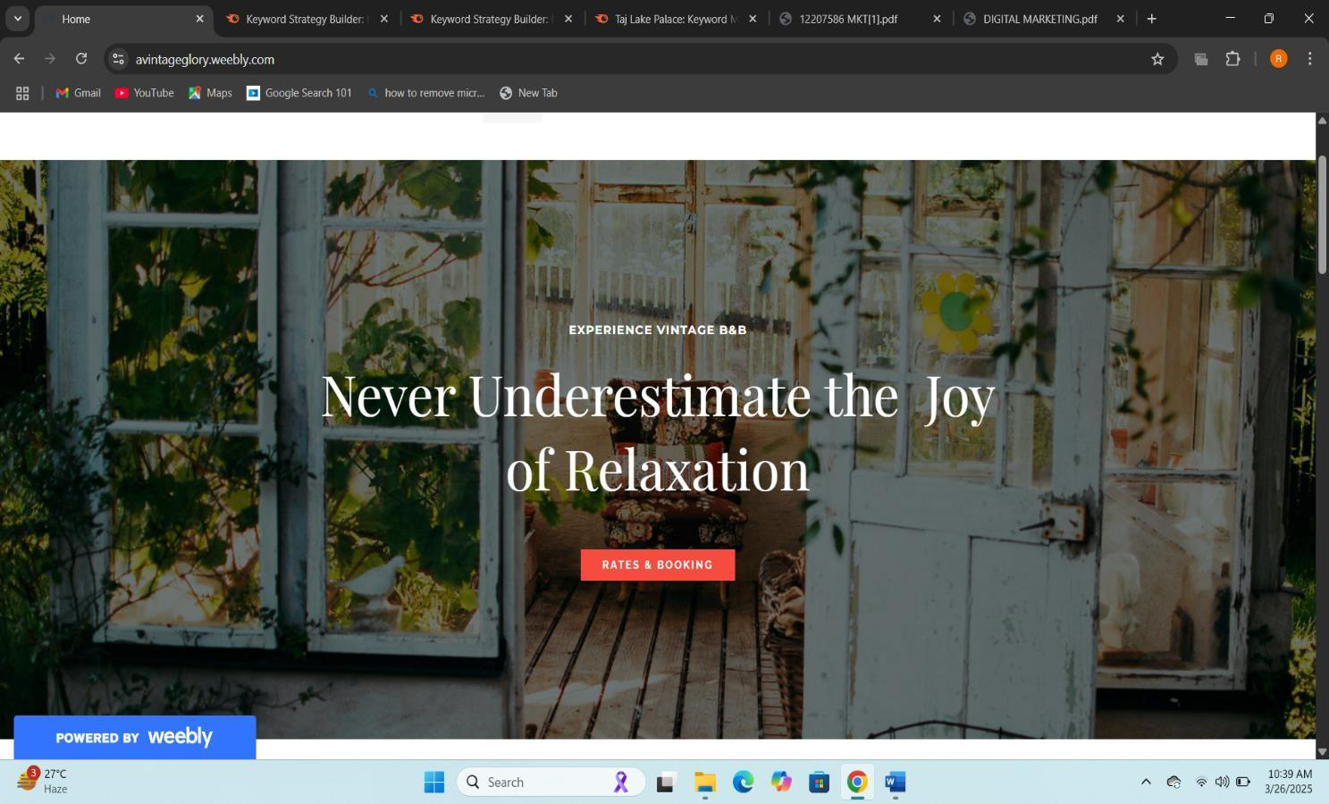

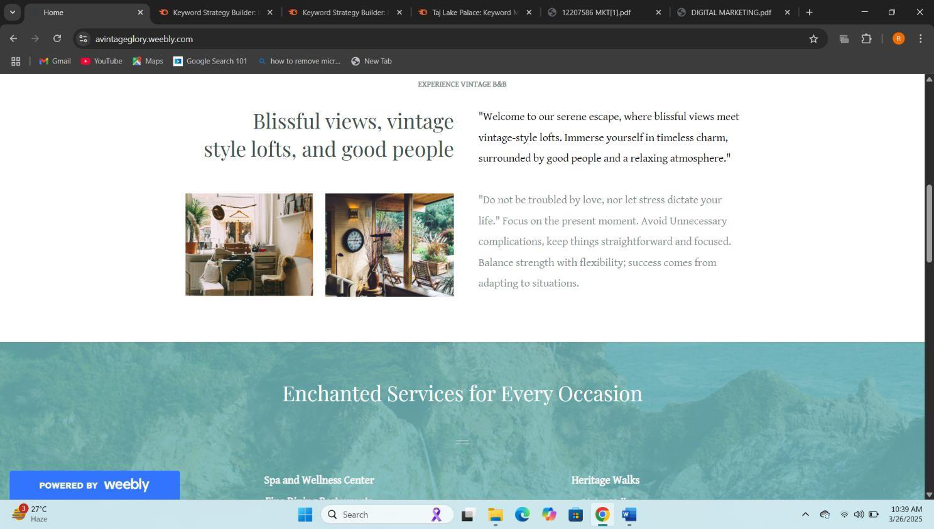

**Services Page:**

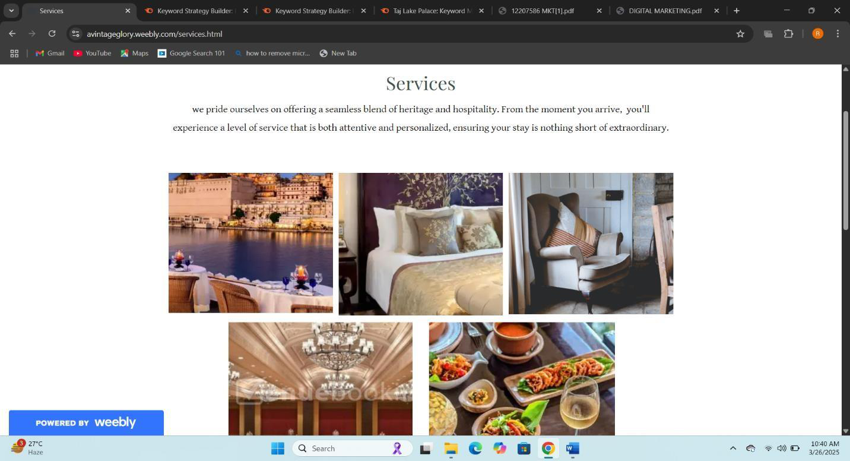

**About Page:**

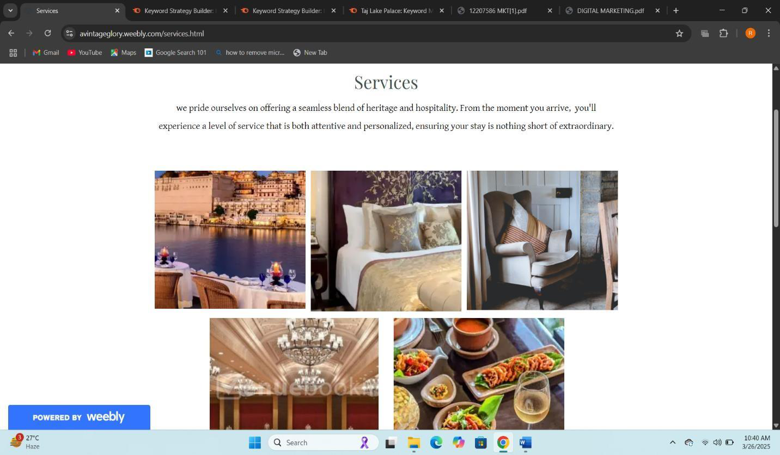

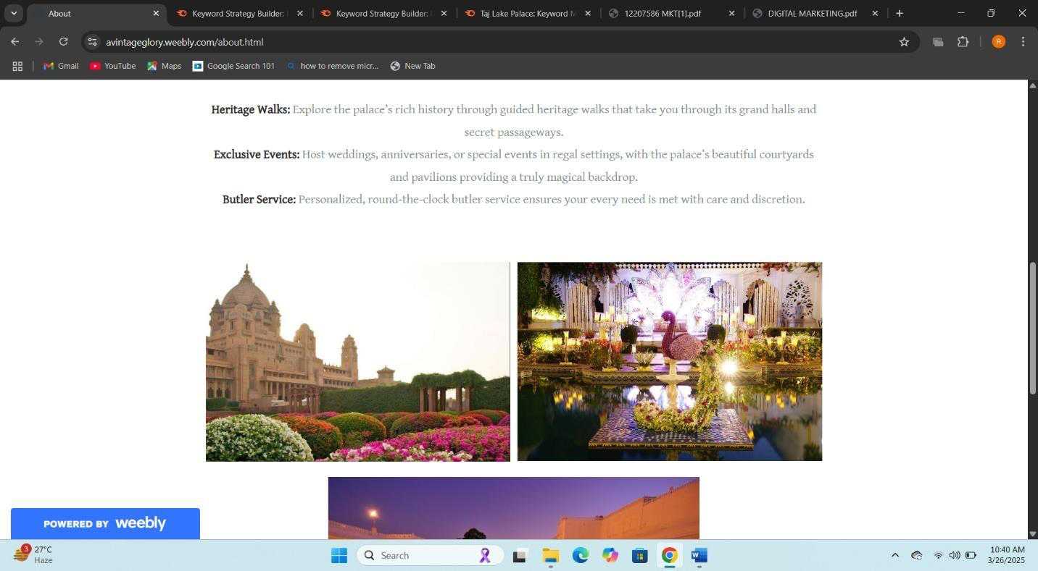

**News Page:**

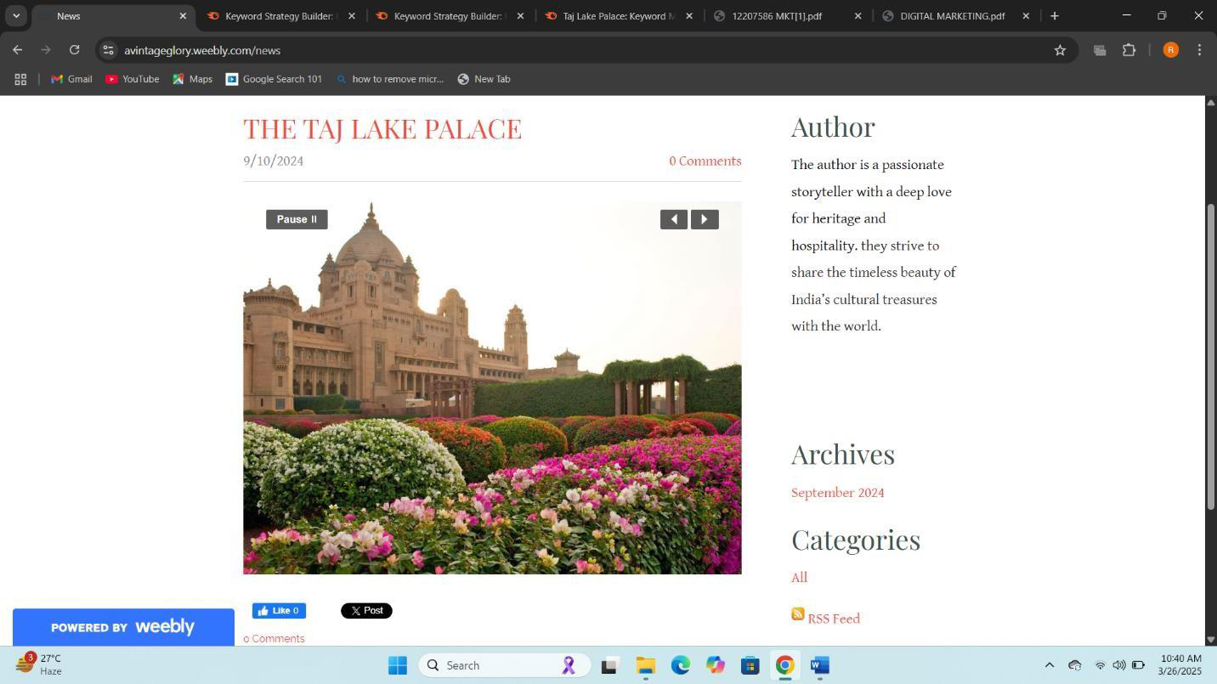

**Contact Page:**

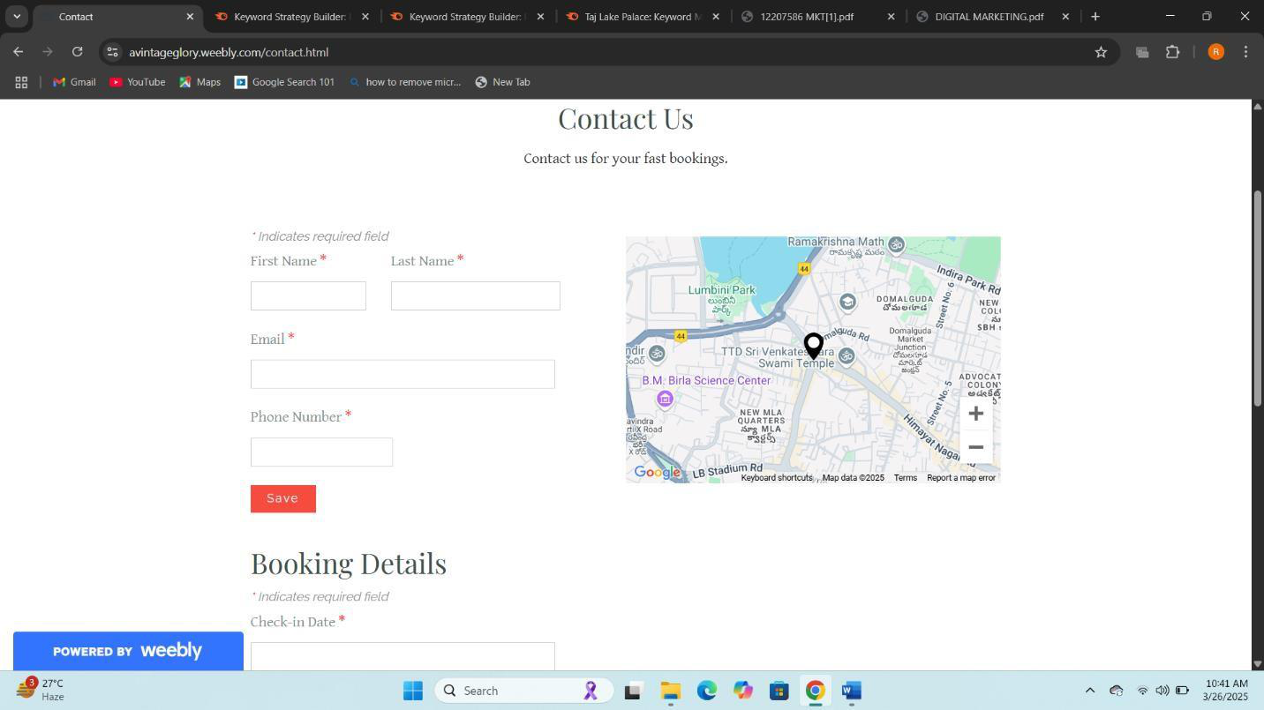

**What is SEO?**

SEO (Search Engine Optimization) is the practice of optimizing

websites and content to improve their visibility and ranking on search

engines like Google, Bing, and Yahoo. The goal of SEO is to attract more

organic (non-paid) traffic by ensuring that a website or webpage

appears higher in search engine results pages (SERPs) for relevant

keywords or phrases.

Key Elements of SEO:

1.On-Page SEO:   
•Optimizing the content on your website.

•Using relevant keywords in titles, headings, meta

descriptions, and body text.

•Improving site speed, mobile-friendliness, and URL

structure.

2.Off-Page SEO:   
•Building backlinks from other trusted websites.

•Social media engagement and promotions. •Online reputation management.

3.Technical SEO:   
•Ensuring the website is crawlable and indexable by search

engines.

•Creating an XML sitemap.

•Fixing broken links and ensuring proper redirects.

4.Content:   
•Creating high-quality, relevant, and engaging content that

provides value to users.

•Using images, videos, and infographics to make the content

appealing   
•Creating high-quality, relevant, and engaging content that

provides value to users.

•Using images, videos, and infographics to make the content

appealing.

5.Keyword Research:   
•Identifying the terms and phrases potential visitors are

searching for.

•Using tools like Google Keyword Planner or SEMrush for

analysis.

6.User Experience(UX):   
•Ensuring the website is easy to navigate.

•Making the site responsive on different devices.

Benefits of SEO:

•Increases organic website traffic.

•Builds trust and credibility with users.

•Enhances user experience.

•Cost-effective compared to paid advertising.

•Provides measurable results (through tools like Google Analytics).

Google Analytics:

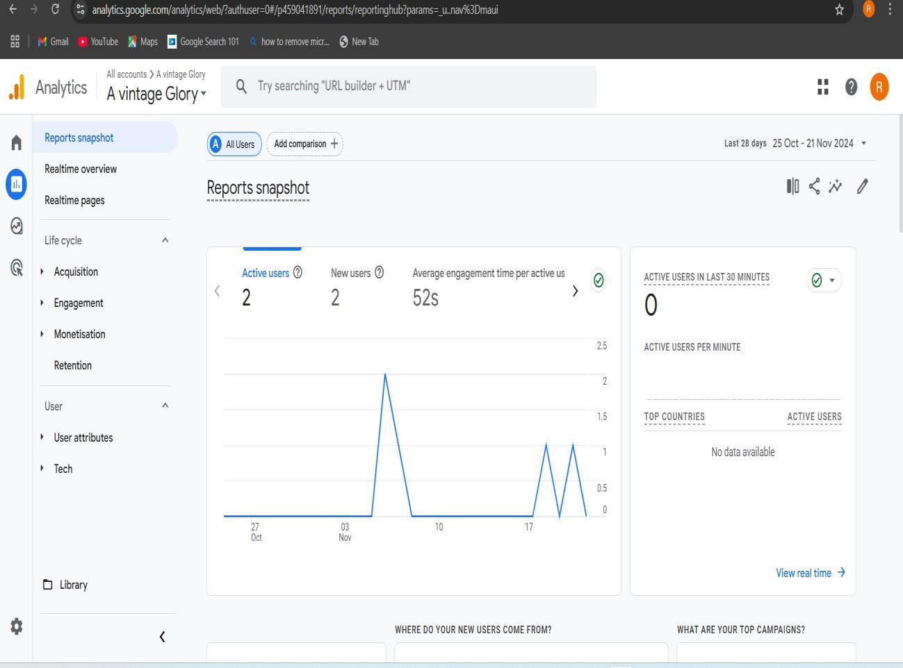

**1.Visitor Tracking and Audience Insights :**

•**Objective:** Understand who is visiting your blog, YouTube, Website.

•**Objective:** Track specific goals like new followers, video views, or newsletter sign-ups.

•**Metrics Tracked:** Goal completions, conversion rate, and behavior flow. •**Insight:** Measures the effectiveness of calls-to-action (CTAs) and allows you to refine them based on what’s generating engagement or conversions. •and Instagram pages.

•**Metrics Tracked:** Audience demographics (age, location), session duration, bounce rate, and new vs. returning visitors.

•**Insight:** Helps determine if the content is reaching the intended audience

(students, parents, prospective applicants) and can guide content

adjustments.

**2. Engagement and Content Analysis :**

•**Objective:** Evaluate which content is resonating most with users.

•**Metrics Tracked:** Page views, average time on page, most viewed posts,

and user flow.

•**Insight:** Identifies popular posts (e.g., government vs. private colleges,

specific fields like medical or engineering), allowing you to prioritize similar

content.

**3. Traffic Sources and Campaign Effectiveness :**

•**Objective:** Measure the impact of social media promotions and Google Ads

on blog traffic.

•**Metrics Tracked:** Source/medium (organic, social, direct), referral sources,

and campaign tracking.

•**Insight:** Shows which platforms (e.g., Instagram, YouTube) and campaigns

are driving the most traffic, helping optimize future ad spending and social

media strategies.

**4. Conversion Tracking and User Goals :**

•**Objective:** Track specific goals like new followers, video views, or newsletter

sign-ups.

•**Metrics Tracked:** Goal completions, conversion rate, and behavior flow. •**Insight:** Measures the effectiveness of calls-to-action (CTAs) and allows you

to refine them based on what’s generating engagement or conversions.

**Keyword Research:**   
 Keyword research is a crucial aspect of Search Engine Optimization (SEO) that helps in identifying high-traffic, relevant keywords to improve a website’s visibility. The process involves analysing keyword search volume, competition, and relevance to ensure effective optimization.

**Keyword Research Process**   
 To identify the most suitable keywords for my portfolio website, I utilized keyword research tools such as:   
 •Google Keyword Planner – To analyse search volume and competition. •SEMrush– To explore competitor keywords and SEO difficulty.

1.

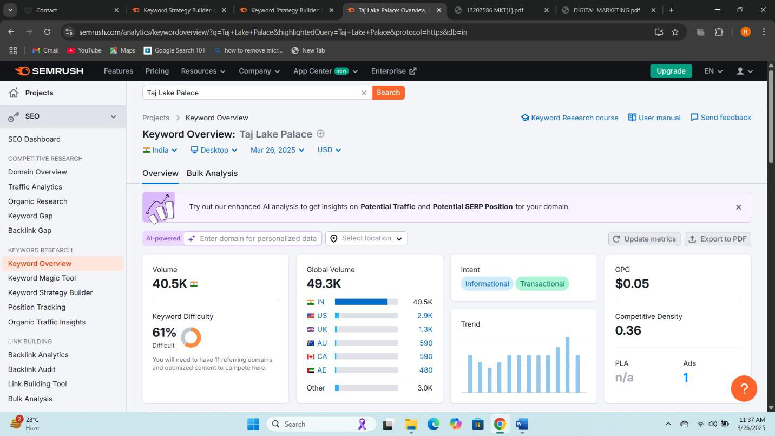

2.

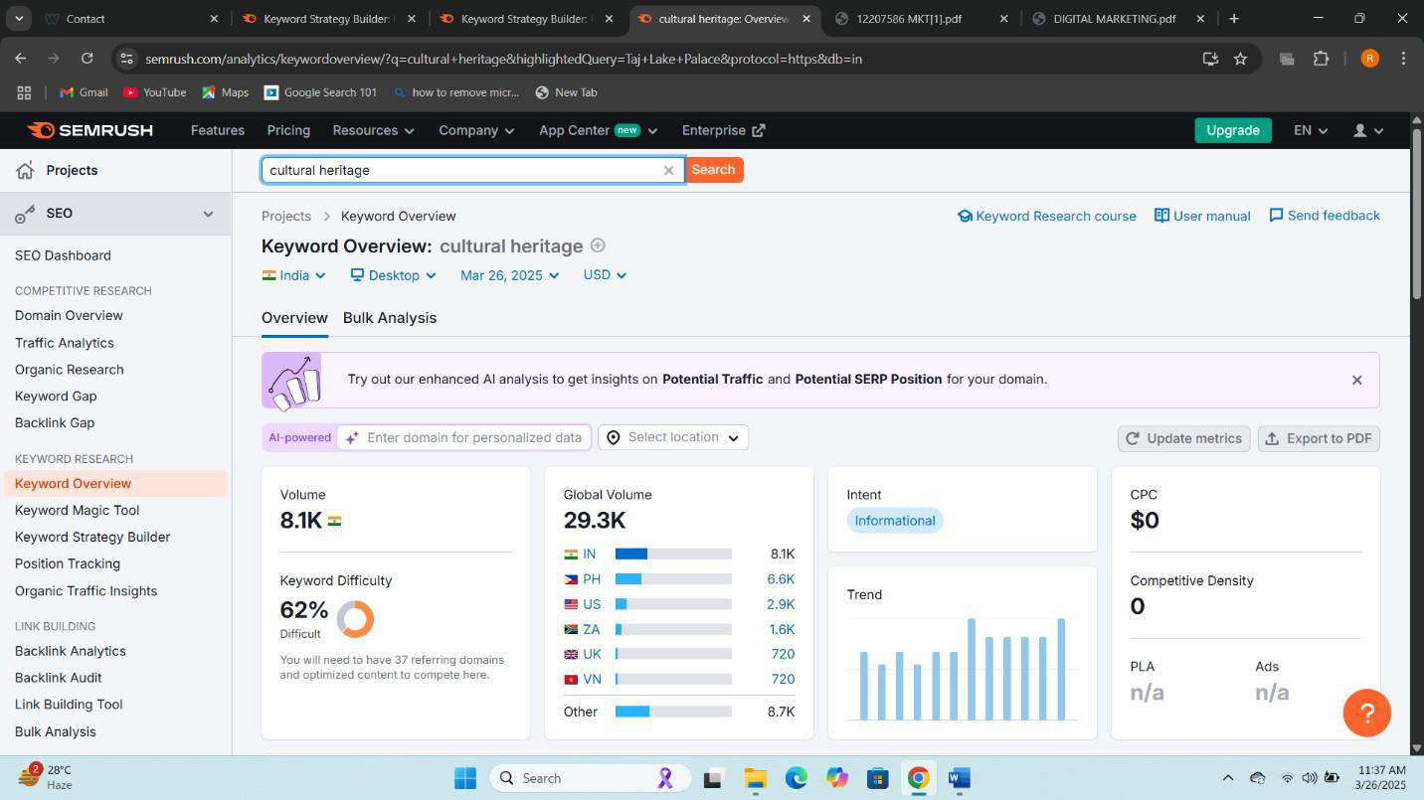

3.

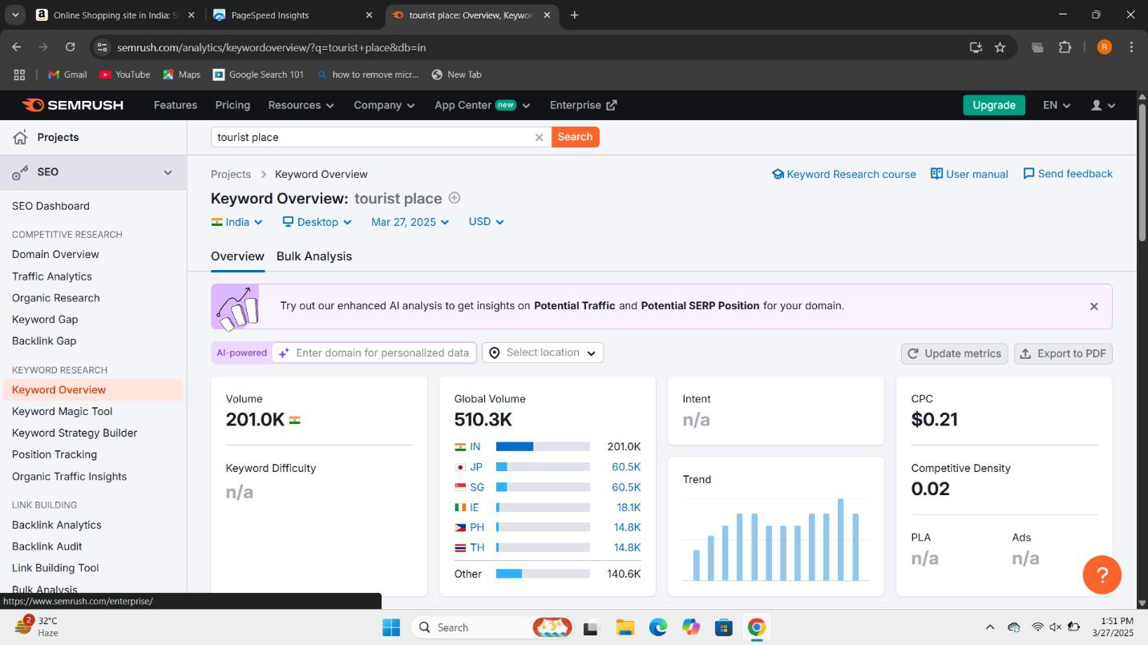

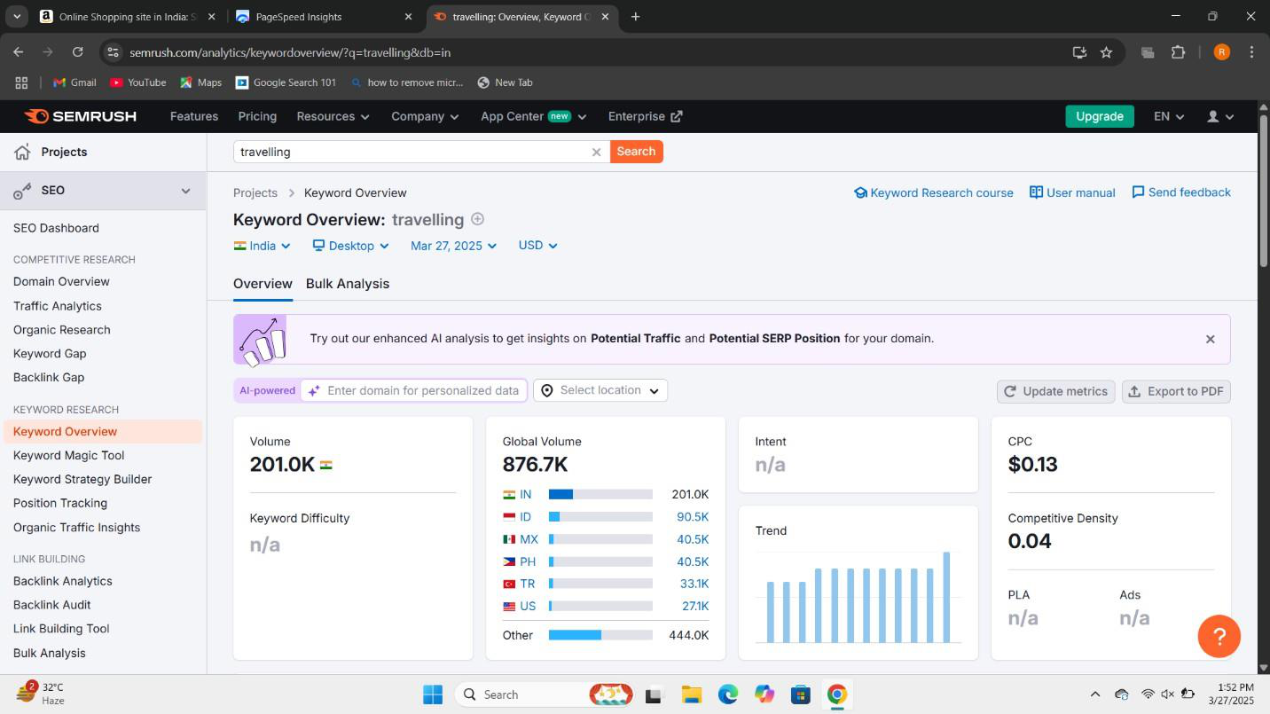

|  |  |  |  |
| --- | --- | --- | --- |
| **Keyword** | **Search volume** | **Competition** | **Justification** |
| Taj Lake Palace | High | High | By attracting users searching for luxury heritage travel, historic  hotels, and Indian palace  experiences, potentially increasing organic traffic and engagement. |
| Cultural Heritage | Medium | Medium | By drawing in users interested in historical sites, traditions, and  heritage tourism, aligning with the website’s focus on vintage and historical themes. |
| Tourist Place | High | High | By attracting travelers looking for popular destinations, helping the website rank higher for travel- related searches and increasing visitor engagement. |
| Travelling | High | High | By targeting a broad audience  interested in exploration, travel  guides, and experiences, increasing visibility among travel enthusiasts. |

•Project Pages: Incorporated relevant keywords in titles and descriptions •Alt Text for Images: Used descriptive, keyword-rich alt tags to enhance search discoverability.

•Internal Linking: Hyperlinked keywords within project descriptions and blog posts to improve navigation and relevance.

**THANK YOU**